**Digital Nurture 4.0 Week 6**

**REACT**

**Mandatory Hands On**

**File name: 1. ReactJS-HOL**

**Step 1: Install Node.js and NPM**

1. Go to <https://nodejs.org/en/download/>
2. Download and install Node.js (LTS version).
3. After installation, open a terminal and check versions:

node -v

npm -v

**Step 2: Open VS Code**

1. Open **Visual Studio Code**.
2. Press Ctrl + Shift + ~ to open **Terminal** inside VS Code.

**Step 3: Install create-react-app**

npm install -g create-react-app

**Step 4: Create Your React App**

npx create-react-app myfirstreact

**Step 5: Open the Project in VS Code**

cd myfirstreact

code .

**Step 6: Edit the App**

1. Go to **src/App.js**
2. Delete all the code inside it.
3. Paste this code:

import React from 'react';

function App() {

return (

<div style={{ textAlign: 'center', marginTop: '50px' }}>

<h1 style={{ fontWeight: 'bold' }}>Welcome the first session of React</h1>

</div>

);

}

export default App;

1. Save the file (Ctrl + S)

**Step 7: Run the App**

Back in the **VS Code terminal**, type:

npm start

**Output:**

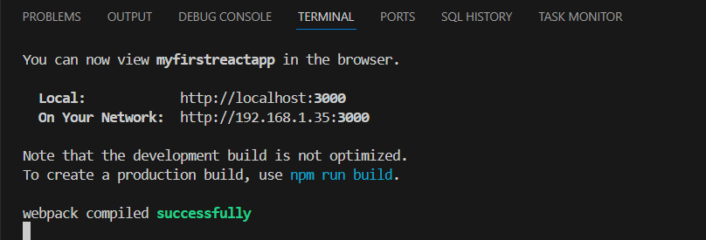

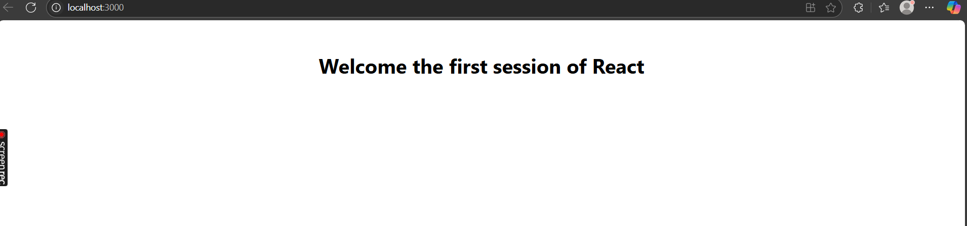

**File name: 2. ReactJS-HOL**

**Step 1: Create the React App**

Open the terminal in VS Code and run:

npx create-react-app StudentApp

cd StudentApp

**Step 2: Create Components Folder**

Inside the src folder:

* Create a new folder named **Components**

**Step 3: Create Home.js**

Inside src/Components/Home.js, paste:

import React, { Component } from 'react';

class Home extends Component {

render() {

return (

<div>

<h1>Welcome to the Home page of Student Management Portal</h1>

</div>

);

}

}

export default Home;

**Step 4: Create About.js**

Inside src/Components/About.js

import React, { Component } from 'react';

class About extends Component {

render() {

return (

<div>

<h1>Welcome to the About page of Student Management Portal</h1>

</div>

);

}

}

export default About;

**Step 5: Create Contact.js**

Inside src/Components/Contact.js

import React, { Component } from 'react';

class Contact extends Component {

render() {

return (

<div>

<h1>Welcome to the Contact page of Student Management Portal</h1>

</div>

);

}

}

export default Contact;

**Step 6: Edit App.js to Render Components**

Open src/App.js and replace the existing code with:

import React from 'react';

import Home from './Components/Home';

import About from './Components/About';

import Contact from './Components/Contact';

function App() {

return (

<div>

<Home />

<About />

<Contact />

</div>

);

}

export default App;

**Step 7: Run the App**

In the VS Code terminal, run:

npm start

**OUTPUT:**

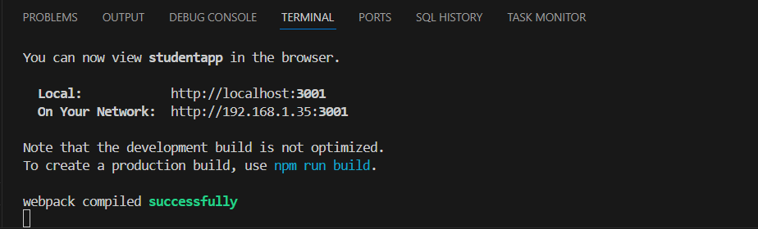

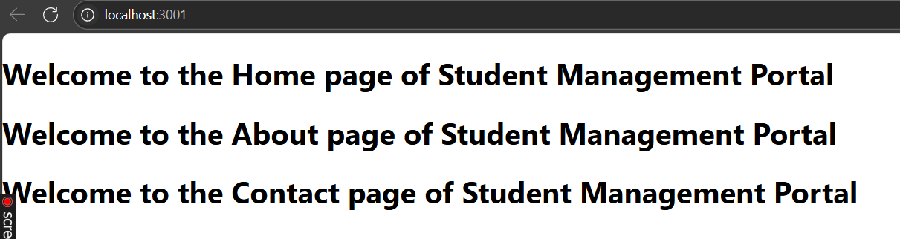

**File name: 3. ReactJS-HOL**

**Step 1: Create React Project**

In VS Code terminal

npx create-react-app scorecalculatorapp

cd scorecalculatorapp

**Step 2: Create Component**

Inside src, create a folder named components and a file named CalculateScore.js inside it.

**src/components/CalculateScore.js**

import React, { useState } from 'react';

import '../Stylesheets/mystyle.css';

function CalculateScore() {

const [name, setName] = useState('');

const [school, setSchool] = useState('');

const [total, setTotal] = useState('');

const [goal, setGoal] = useState('');

const [average, setAverage] = useState(null);

const handleCalculate = () => {

const totalMarks = parseFloat(total);

const goalMarks = parseFloat(goal);

if (!isNaN(totalMarks) && !isNaN(goalMarks)) {

const avg = (totalMarks + goalMarks) / 2;

setAverage(avg.toFixed(2));

} else {

setAverage("Invalid input");

}

};

return (

<div className="container">

<h2>Student Score Calculator</h2>

<input type="text" placeholder="Enter Name" onChange={e => setName(e.target.value)} />

<input type="text" placeholder="Enter School" onChange={e => setSchool(e.target.value)} />

<input type="number" placeholder="Enter Total Score" onChange={e => setTotal(e.target.value)} />

<input type="number" placeholder="Enter Goal Score" onChange={e => setGoal(e.target.value)} />

<button onClick={handleCalculate}>Calculate Average</button>

{average && (

<div className="result">

<p><strong>Name:</strong> {name}</p>

<p><strong>School:</strong> {school}</p>

<p><strong>Average Score:</strong> {average}</p>

</div>

)}

</div>

);

}

export default CalculateScore;

**Step 3: Add Stylesheet**

Create a folder Stylesheets inside src, and then create a file mystyle.css.

**src/Stylesheets/mystyle.css**

.container {

width: 400px;

margin: 50px auto;

background-color: #f7f7f7;

padding: 20px;

border-radius: 12px;

box-shadow: 0 0 10px rgba(0,0,0,0.2);

text-align: center;

}

input {

display: block;

width: 90%;

margin: 10px auto;

padding: 8px;

font-size: 16px;

}

button {

background-color: #007bff;

color: white;

padding: 10px 20px;

margin-top: 10px;

border: none;

border-radius: 5px;

cursor: pointer;

}

button:hover {

background-color: #0056b3;

}

.result {

margin-top: 20px;

font-size: 18px;

}

**Step 4: Edit App.js**

Replace existing code in App.js with:

**src/App.js**

import React from 'react';

import './App.css';

import CalculateScore from './components/CalculateScore';

function App() {

return (

<div className="App">

<CalculateScore />

</div>

);

}

export default App;

Step 5: Run the App

npm start

**OTUPUT:**

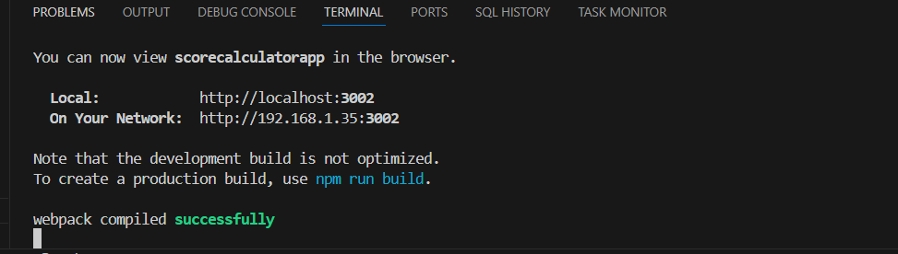

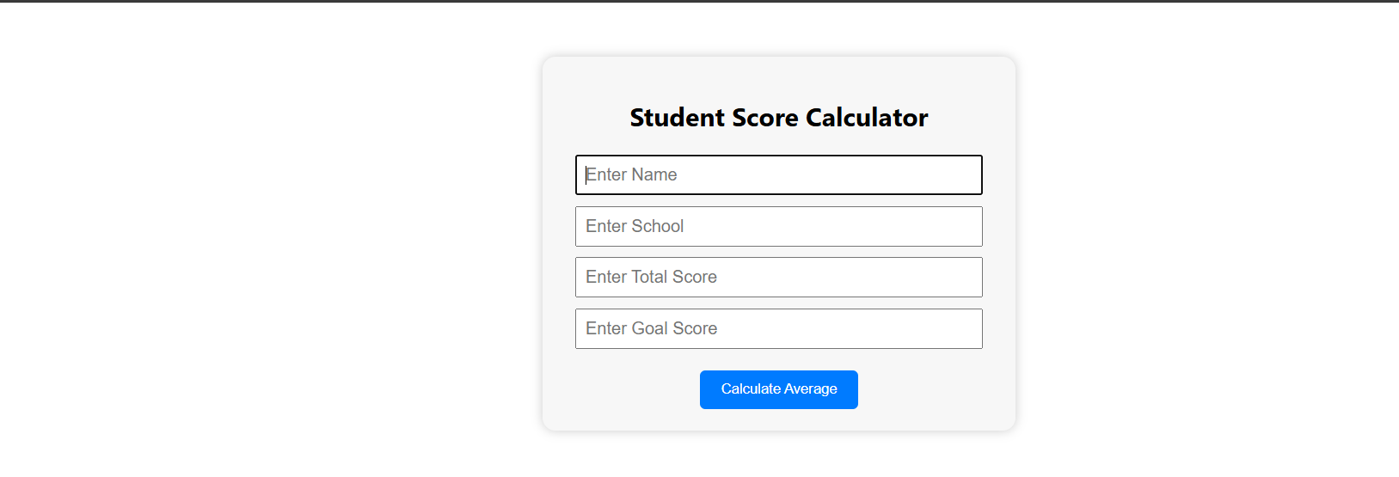

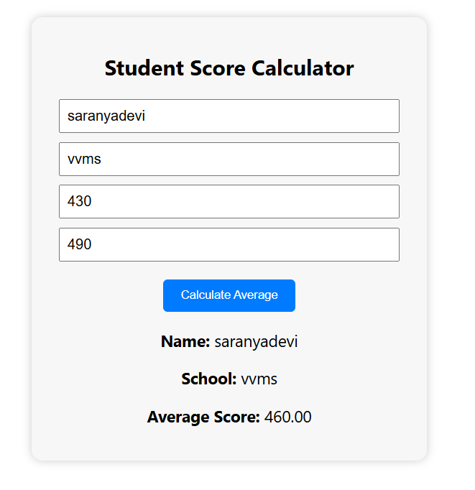

**File name: 4. ReactJS-HOL**

**Step 1: Create a new React app**

In VS Code terminal,

npx create-react-app blogapp

cd blogapp

**Step 2: Create Post.js**

This file defines a **stateless functional component** to display a single post.

src/Post.js

import React from 'react';

const Post = ({ title, body }) => {

return (

<div style={{ border: "1px solid #ccc", margin: "10px", padding: "10px" }}>

<h3>{title}</h3>

<p>{body}</p>

</div>

);

};

export default Post;

**Step 3: Create Posts.js**

src/Posts.js

import React, { Component } from 'react';

import Post from './Post';

class Posts extends Component {

constructor(props) {

super(props);

this.state = {

posts: [],

error: null

};

}

loadPosts = () => {

fetch('https://jsonplaceholder.typicode.com/posts')

.then(response => {

if (!response.ok) throw new Error("Error fetching posts");

return response.json();

})

.then(data => this.setState({ posts: data }))

.catch(err => this.setState({ error: err.message }));

};

componentDidMount() {

this.loadPosts();

}

componentDidCatch(error, info) {

alert("An error occurred: " + error);

}

render() {

const { posts, error } = this.state;

if (error) {

return <h2 style={{ color: 'red' }}>Error: {error}</h2>;

}

return (

<div>

<h2>Blog Posts</h2>

{posts.slice(0, 10).map(post => (

<Post key={post.id} title={post.title} body={post.body} />

))}

</div>

);

}

}

export default Posts;

**Step 4: Update App.js to Include Posts Component**

src/App.js

import React from 'react';

import './App.css';

import Posts from './Posts';

function App() {

return (

<div className="App">

<h1>Welcome to BlogApp</h1>

<Posts />

</div>

);

}

export default App;

**Step 5: Run the Application**

In terminal:

npm start

**Output:**

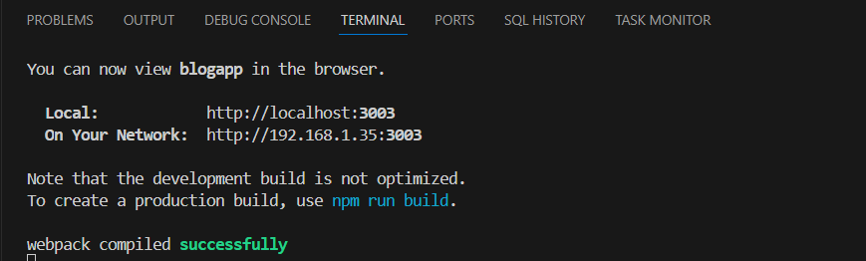

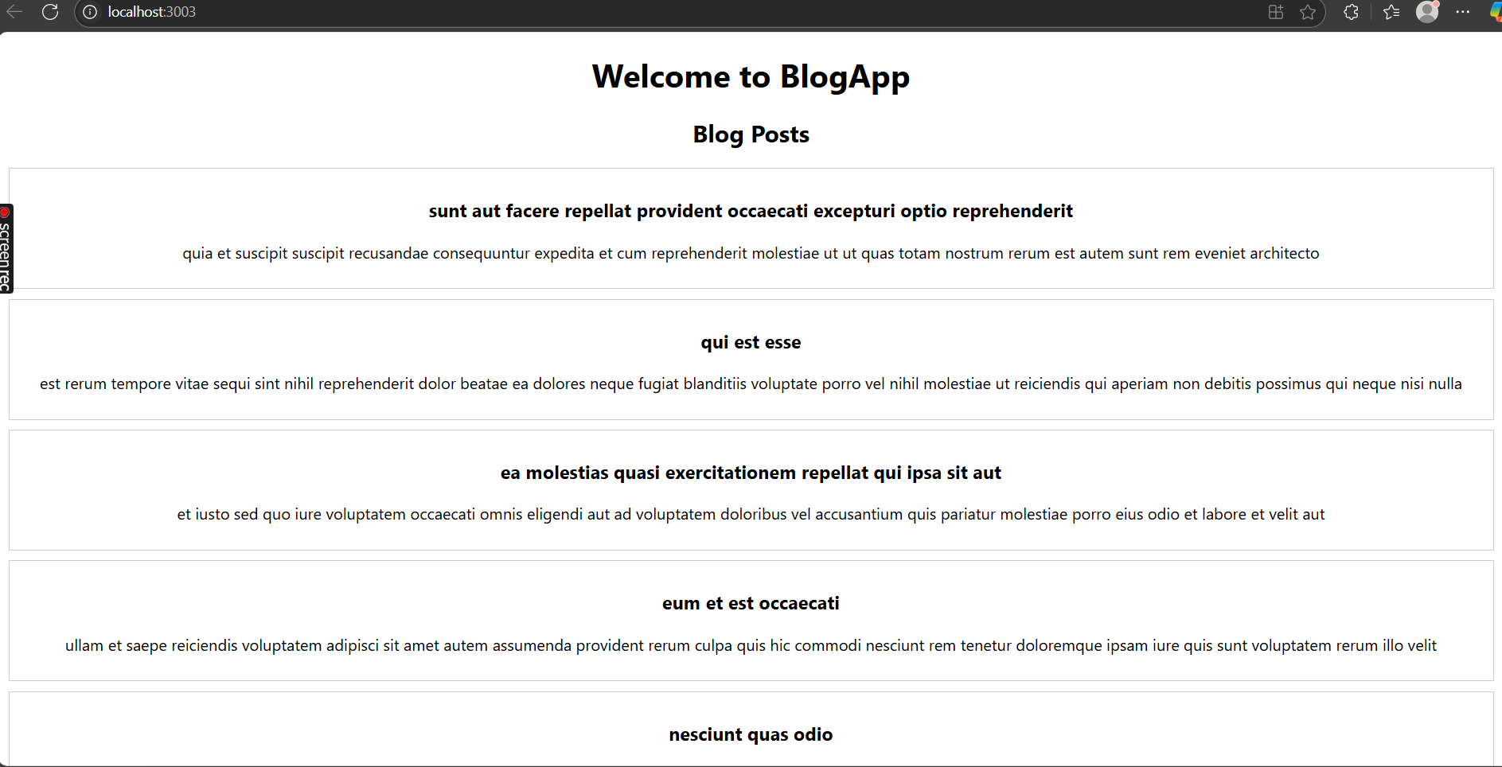

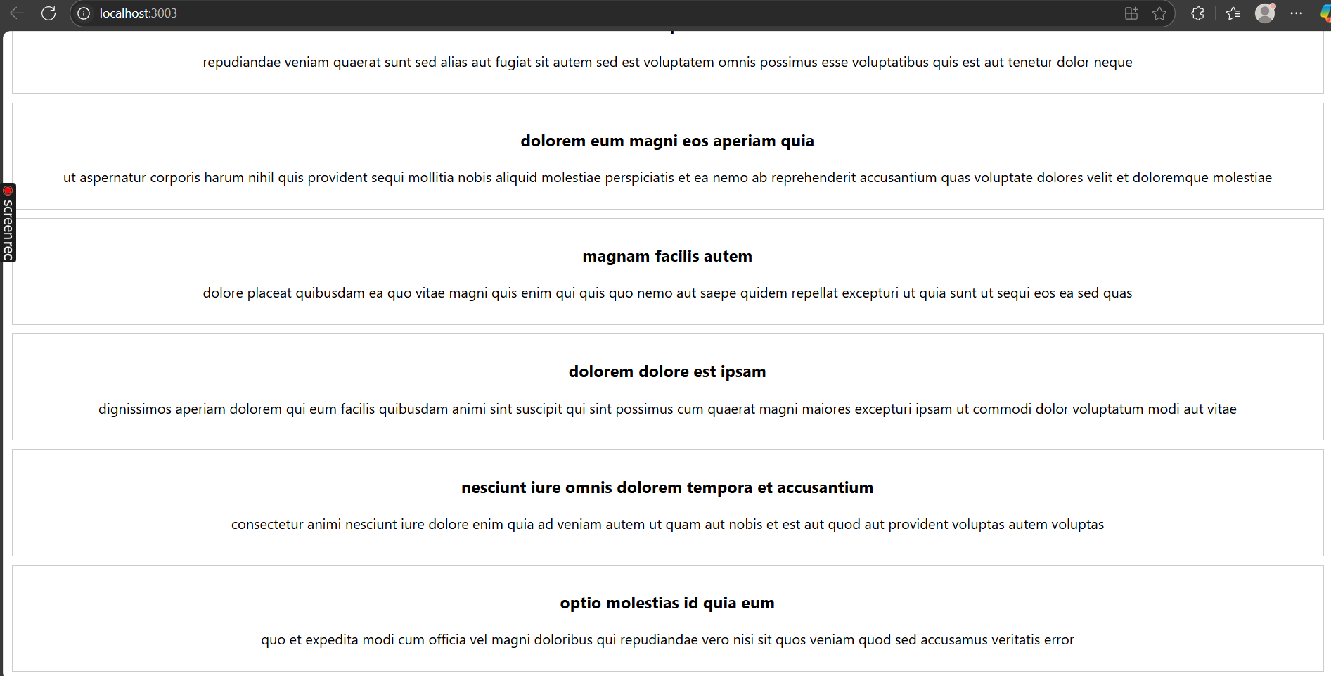

**File name: 5. ReactJS-HOL**

**Step 1: Unzip & Open Project**

1. Unzip the provided project folder.
2. Open Command Prompt, go into the unzipped folder**:**

**cd path-to-your-folder**

**Step 2: Install Dependencies**

npm install

Step 3: Open in VS Code

code .

**Step 4: Create CSS Module**

Inside src/components/ (or src/), create:

CohortDetails.module.css

.cohort-container {

  padding: 20px;

  font-family: Arial, sans-serif;

}

.cohort-heading {

  font-size: 24px;

  font-weight: bold;

  margin-bottom: 20px;

}

.cohort-cards {

  display: flex;

  gap: 20px;

  flex-wrap: wrap;

}

.cohort-card {

  border: 1px solid #ccc;

  border-radius: 10px;

  padding: 15px;

  width: 260px;

  background-color: white;

  box-shadow: 0px 2px 5px rgba(0,0,0,0.05);

}

.cohort-id {

  font-size: 16px;

  margin-bottom: 10px;

}

**Step 5: Edit CohortDetails.js Component**

Example code if you are not given a starting file:

CohortDetails.js

import React from "react";

import "./CohortDetails.module.css";

const cohorts = [

  {

    id: "INTADMDF10 - .NET FSD",

    startDate: "22-Feb-2022",

    status: "Scheduled",

    coach: "Aathma",

    trainer: "Jojo Jose",

    color: "blue",

  },

  {

    id: "ADM21JF014 - Java FSD",

    startDate: "10-Sep-2021",

    status: "Ongoing",

    coach: "Apoorv",

    trainer: "Elisa Smith",

    color: "green",

  },

  {

    id: "CDBJF21025 - Java FSD",

    startDate: "24-Dec-2021",

    status: "Ongoing",

    coach: "Aathma",

    trainer: "John Doe",

    color: "green",

  },

];

const CohortList = () => {

  return (

    <div className="cohort-container">

      <h2 className="cohort-heading">Cohorts Details</h2>

      <div className="cohort-cards">

        {cohorts.map((cohort, index) => (

          <div className="cohort-card" key={index}>

            <p className="cohort-id" style={{ color: cohort.color }}>

              <b>{cohort.id}</b>

            </p>

            <p><b>Started On</b><br />{cohort.startDate}</p>

            <p><b>Current Status</b><br />{cohort.status}</p>

            <p><b>Coach</b><br />{cohort.coach}</p>

            <p><b>Trainer</b><br />{cohort.trainer}</p>

          </div>

        ))}

      </div>

    </div>

  );

};

export default CohortList;

**Step 6: Sample App Usage**

Edit App.js to test:

import React from 'react';

import CohortDetails from './CohortDetails';

function App() {

return (

<div>

<CohortDetails

name="React Bootcamp"

startDate="2025-07-01"

endDate="2025-07-30"

status="ongoing"

/>

<CohortDetails

name="Angular Basics"

startDate="2025-06-01"

endDate="2025-06-30"

status="completed"

/>

</div>

);

}

export default App;

Step 7: Run the App

npm start

**OUTPUT:**

